Day 04 Homework

Use JOINs and UNIONs to answer the following questions:

# 1. Which region saw the most returned items? For what reasons?

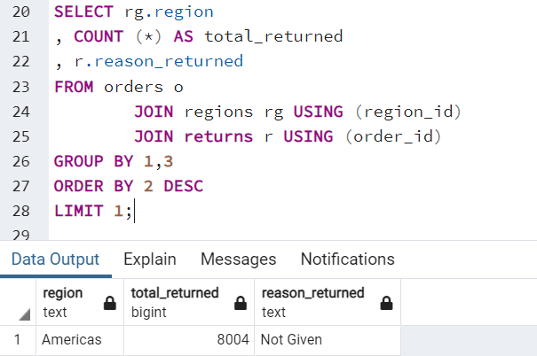

SELECT rg.region

, COUNT (*) AS total_returned

, r.reason_returned

FROM orders o

JOIN regions rg USING (region_id)

JOIN returns r USING (order_id)

GROUP BY 1,3

ORDER BY 2 DESC

LIMIT 1;

# 2. What product was returned most often?

SELECT p.product_name

, COUNT (*) AS total_return_quantity

FROM orders

JOIN products p USING (product_id)

JOIN returns r USING (order_id)

GROUP BY 1

ORDER BY 2 DESC

LIMIT 1;

# 3. Which of our “top vendors” (3M, Apple, Avery, Cisco, Epson, HewlettPackard (HP, Hewlett, Packard), Logitech, Panasonic, Samsung, and Xerox) saw the most returns?

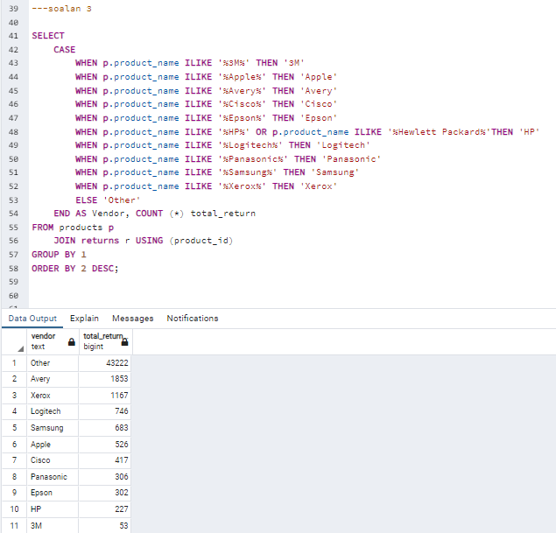

SELECT

CASE

WHEN p.product_name ILIKE '%3M%' THEN '3M'

WHEN p.product_name ILIKE '%Apple%' THEN 'Apple'

WHEN p.product_name ILIKE '%Avery%' THEN 'Avery'

WHEN p.product_name ILIKE '%Cisco%' THEN 'Cisco'

WHEN p.product_name ILIKE '%Epson%' THEN 'Epson'

WHEN p.product_name ILIKE '%HP%' OR p.product_name ILIKE '%Hewlett Packard%'THEN 'HP'

WHEN p.product_name ILIKE '%Logitech%' THEN 'Logitech'

WHEN p.product_name ILIKE '%Panasonic%' THEN 'Panasonic'

WHEN p.product_name ILIKE '%Samsung%' THEN 'Samsung'

WHEN p.product_name ILIKE '%Xerox%' THEN 'Xerox'

ELSE 'Other'

END AS Vendor, COUNT (*) total_return

FROM products p

JOIN returns r USING (product_id)

GROUP BY 1

ORDER BY 2 DESC;

# 4. Which product is most profitable with the consumer segment?

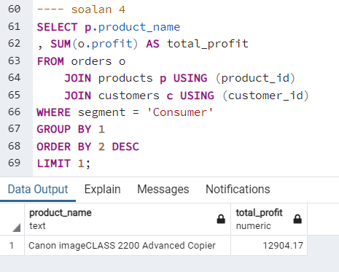

SELECT p.product_name

, SUM(o.profit) AS total_profit

FROM orders o

JOIN products p USING (product_id)

JOIN customers c USING (customer_id)

WHERE segment = 'Consumer'

GROUP BY 1

ORDER BY 2 DESC

LIMIT 1;